


www.summerfaceoff.com
info@summerfaceoff.com
info@orlandolacrosse.com

To all LCO Families,
Here is your first update in preparation for the 2025 Orlando Summer Face Off Tournament held on May 31-June 1.
*Use the website - www.summerfaceoff.com - most information is posted or linked on this page
*Waivers - all registered LCO players have already executed the waiver required for the event through your LCO registration - no action required.
*Family Planner document - linked on the home page of the website - please read as it provides useful and during event information for your planning
*Parking - parking is a challenge and is referenced several times in the Family Planner.
>Carpooling recommended
>Omni charges $20 per vehicle and Austin Tindall $7 per vehicle
*Schedules for event - schedules will come out over the coming weekend and will be posted on the Schedules page and on the Tourney Machine App. We highly recommended downloading the app. https://www.summerfaceoff.com/schedule-results
>All teams play Saturday and Sunday - when schedule comes out if playoffs are dependent on pool results the Sunday schedule will not be posted until Saturday night - each team gets a minimum of four games

Below you can see a screenshot of what you will see on the home page of www.summerfaceoff.com to access all links/postings as referenced above.

Thank you,
Orlando Lacrosse Staff

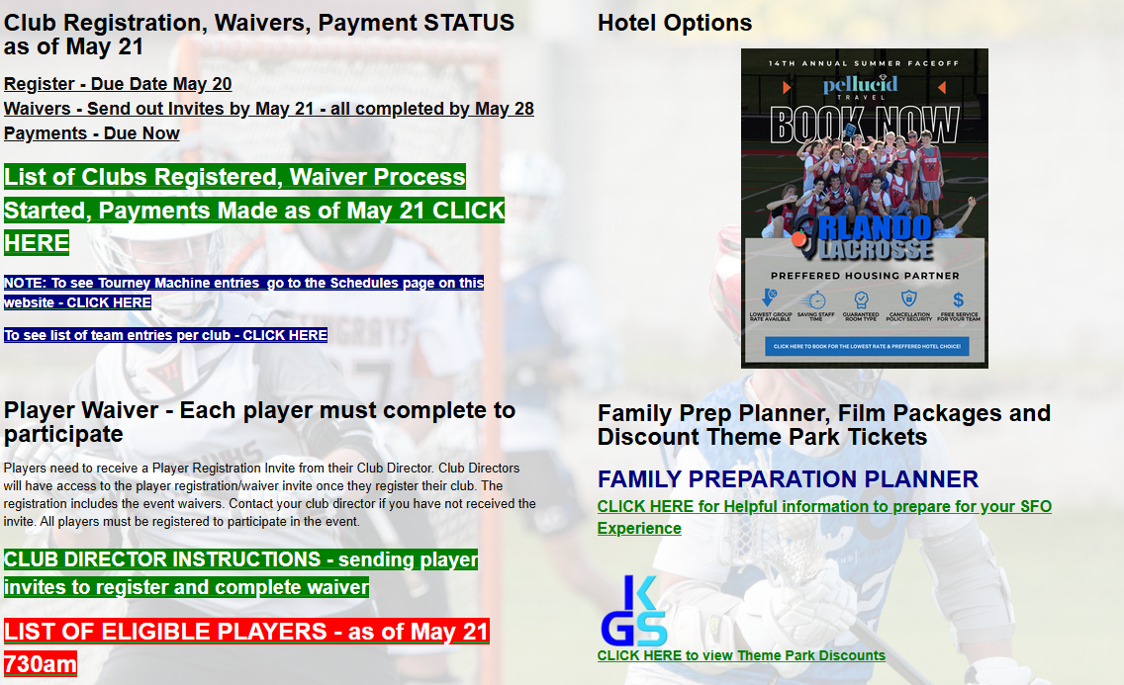

Reminder that spectators are not allowed on the stadium field and track at Boone High School.
Please sit in the West Stands only.

LCO High School Training Camp #1 and Youth Training Camp #3
Saturday, May 3 at Boone HS
1000E. Kaley Street
*Wear a reversible jersey
*Bring your own hydration needs and all equipment
*Arrive at least 15 minutes early to your session
8u 900-1030am
10u 900-1030am
12u 1030-1200pm
14u 1030-1200pm
Class of 2028 and 2029 1200-130
Class of 2026 and 2027 130-300

ORDER UNIFORMS – You will have to contact the vendor directly for delivery windows
https://signaturelocker.com/collections/lacrosse-club-orlando-0052

Lacrosse Club Orlando (LCO) May 6 UPDATE
*also posted on the LCO Summer Manager page for reference.
LCO Summer Manager - Orlando Lacrosse

UPDATE CONTENTS:
*Practice schedules through May 15 are posted for all age groups – they will be updated for after May 15 once we start to reflect team practice schedules
*Youth 14u and below starts April 26
*High School – current grade 9 and above starts May 10
*Uniforms – may wear uniform from last year or see info on LCO Summer Manager page
*How to access your LCO account
*Updates to all information is posted each Sunday or Monday going into each week moving forward.
YOUTH 14u, 12u, 10u, 8u starts May 3 at Boone High School. Note that youth practices will also take place at Lake Highland Prep. Sites are reflected in the posted schedule linked on the LCO Summer Manager page.
We are Looking forward to kicking off the youth training camp on Saturday 4/26. Please share registration with anyone you know who might be interested as we are just over a week away from starting.
HIGH SCHOOL – current grade 9 and above starts May 10
Please encourage your team mates to register soon so we can plan accordingly.
HOW TO ACCESS YOUR LCO ACCOUNT
Use this link and click on the log in link located in the top right hand corner
https://orlandolacrossecompany.leagueapps.com/clubteams/4294144-2025-lacrosse-club-orlando-summer-program
UPDATES SENT WEEKLY
Updates will include any changes to the daily activity schedule and other planning notes.
First event is May 31-June 1. www.summerfaceoff.com

